Type of Manuscript:
Research / Review/ Original/ Short Communication/ News / Case Study (Select any one)

Development of cefdinir loaded functionalized carbon nanotubes dry powder inhaler for the treatment of cystic fibrosis

Title (Times New Roman front 14 Bold)

Krishnat D. Dhekale, Sharvil Patil, Ravindra N. Kamble*

Author (S) (Times New Roman front 11 Bold)

Department of Pharmaceutics, Poona College of Pharmacy, Bharati Vidyapeeth University, Erandwane, Pune 411038, Maharashtra, India.

Author (S) Affiliation (Times New Roman front 10)

*Corresponding author:
Department of Pharmaceutics,
Poona College of Pharmacy,
BharatiVidyapeeth University,
Erandwane, Pune 411038, Maharashtra, India.
E-mail address: kravi_73@rediffmail.com
Tel: + 912025437237; Fax: + 912025439383.

ABSTRACT:
(Times New Roman front 11 Bold Capital)

Content (Times New Roman front 10)

A dry-powder inhaler (DPI) carries medication to lungs as a dry powder, useful against respiratory diseases. The current research was endeavoured to examine the capabilities of Multi-walled carbon nanotubes (MWCNT) as a pulmonary transporter for directing cefdinir to cystic fibrosis (CF). Functionalized MWCNTs were loaded with cefdinir to formulate DPI (F-CEF FMWCNTs DPI) having efficient treatment against lung infections and were evaluated successfully. The outcomes demonstrated that cefdinir loaded FMWCNTs were non-toxic and accomplished 79.73 % entrapment with better flow properties. The optimized formulation had Mass Median Aerodynamic Diameter (MMAD), Fine particle fraction (FPF), and particle size of 3.45±0.09 μm, 58.52±1.06%, 5.25 ± 0.03 μm (CEF FMWCNT DPI) and 4. 29±0.16μm 38.74±1.02%, 7.54 ± 0.02 μm (C-DPI) respectively. The loaded nanotubes showed 72. 63 % release after 15 hours in a controlled manner. The outcome of work recognized a unique, simple, and stable product having improved drug loading and increased dispersibility of carbon nanotubes (CNTs) thus improved bioavailability at a lung infection place with less adverse actions.

KEYWORDS: Dry powder inhaler, Cefdinir, Lung infectious disease, Cystic fibrosis, Wetness Impregnation Method.
(Times New Roman front 11 Bold Capital)

Content (Times New Roman front 10 [at least 5 key words])

INTRODUCTION : (Times New Roman front 11 Bold Capital )

Content (Times New Roman front 10) Pulmonary drug delivery system, increasing lots of significance currently in research area since it empowers the focusing of medication conveyance straightforwardly to lung for local as well as systemic treatment, it has great potential to produce maximum therapeutic benefits and it is an alternative route to the interaction between drugs when two or more medications are used concurrently, it provides local action within the respiratory tract, gives rapid drug action, and reduces systemic side-effects. Due to the drawbacks related to the traditional treatment of different chronic diseases a developing consideration has been given to the development of targeted drug delivery systems¹. High recurrence of dosing of traditional products prompts fundamental poisonousness. Subsequently, controlled delivery carrier systems can give a potential answer for these issues by dropping the recurrence of doses and expanding drug bioavailability can prompt improved patient consistence². (Model citation in text )

DPIs are products through which a DPI of a powder formulation is passed on for foundational or local impact using the aspiratory route³. DPIs have different purposes of points of interest over various procedures for pulmonary delivery, e.g., direct transport of medicine into the lungs utilizing the patient's breath and are continuously being explored as a part for the movement of systemic drugs⁴.Carbon nanotubes (CNTs) are made of carbon frequently allude to single-wall and multi-wall carbon nanotube. The functionalization of multi-wall CNTs comprises of the attesting of natural moieties to their cylindrical structure. Through the functionalization of CNTs, it is conceivable to adjust their physicochemical properties, augmenting their simplicity of dispersion, control, and processability⁵.Functionalization of CNTs gives a connection of natural moiety to nano estimated tubes which encouraged their utilization for targeting purposes, particularly in irresistible infection treatment. The adjustment of CNTs by the introduction of a medication particle onto the walls and/or sides of CNTs is termed as CNT functionalization. This functionalization might be used for their upgraded biocompatibility, improved encapsulation tendency⁶.A few investigations on the fate of nanotubes in the body have proposed that the functionalized CNTs stacked with drug substances could without much of a stretch pass into the cells and further into the cell core, in this manner accomplishing focused on medication delivery both at a cellular and nuclear levels⁷.

As the above interesting properties of FMWCNTs may be a superior DPI carrier system. Cystic fibrosis (CF) is a genetic disorder that affects mostly the lungs^{8, 9}.
Lung infections are treated with antibiotics, which may be given intravenously, inhaled, or by mouth. The lungs of individuals with cystic fibrosis are colonized and infected by bacteria from an early age¹⁰. The "lung infections" category includes: influenza, pneumonia, and other acute lower respiratory infections, these infections are especially common and severe among the poor¹¹. The mechanism of action of cephalosporin’s is it interferes with bacterial cell wall synthesis and defense to lung against bacterial colonization are mucociliary clearance, polymorphonuclear neutrophil phagocytosis, and local production of antibacterial cationic peptides which are poorly effective under conditions of increased viscosity and osmolarity, resulting in chronic lung infection¹².

Cefdinir is an antimicrobial agent approved for the treatment of community-acquired pneumonia, cystic fibrosis, and several other lung infections¹³. Structurally cefdinir is characterized by a vinyl group at the C-3 position, and an acetyl moiety at C-7, which results in a marked increase in antimicrobial activity against both gram positive and negative bacteria, and also enhanced pharmacokinetic properties¹⁴. The drug distributes very well in respiratory tract tissues and fluids.
Cefdinir has a tablet, capsule, and suspension formulations in the market, but they need to be administered frequently and oral bioavailability is low (16 – 21 %). A DPI of cefdinir may have effective results than oral and enhance the bioavailability¹⁵. The conventional oral dosages of cefdinir for treatment of lung infectious diseases have multiple drawbacks such as orally given drugs cannot provide sufficient amount of drug for the lung site that requires increased amounts of dose due to this there is a need to have dosage such as DPI. In this research, the functioned MWCNTs were loaded with cefdinir drug which has efficient treatment against CF lung infections, which is evaluated by particle size, flow properties, release kinetics, in vitro, and in vivo deposition study, and acute inhalation toxicity study.

MATERIALS AND METHODS: (Times New Roman front 11 Bold Capital )

Materials (Times New Roman front 10 Bold)

Multiwall carbon nanotubes were purchased from the Applied Science Innovations Pvt. Ltd, India. Cefdinir was received as a gift sample from Covalent Laboratories Pvt. Ltd, Hyderabad India. All other chemicals were of analytical grade purchased from local suppliers. Content (Times New Roman front 10)

Methods of Functionalization of MWCNTs:
MWCNT were functionalized by the primary basic treatment followed utilization of hydrochloric acid for generation of functionalized MWCNTs (FMWCNT) covalently. By this process, the underlying vital treatment by hydrogen peroxide and hydroxide produced oxidized MWCNTs and later treating with HCl creatdcarboxylated MWCNTs. 500 mg of MWCNT was scattered in 25 ml of the mixture of 25 % ammonium hydroxide and 30% hydrogen peroxide (V: V = 1:1) in a 100 ml round bottom flask, furnished with a condenser and dispersion was warmed to 80ºC and left for 5 h. Later on, the subsequent scattering was diluted in water and removed. The residue was then washed with water up to unbiased pH and the sample was dried in vacuum at 40ºC overnight. The treatment with hydrochloric acid produced carboxylated MWCNTs. In this method 500mg of MWNCTs was placed in round bottom flask and 200 ml of HCl was added. The resultant reaction mixture was stirred using magnetic stirrer for 2 h, then diluted, filtered and washed with ultrapure water dried in vacuum overnight¹⁶.

Characterization of FMWCNT
Both (mass and IR spectroscopy) studied were conducted as per regular standard procedures.
Mass spectrometry (MS) is a method for the mass-to-charge ratio measurement of ions. IR spectra of pure and functionalized MWCNT were noted from 4,000 to 400 cm⁻¹ with and FTIR-8400; Shimadzu Corporation, Kyoto, Japan outfitted with a diffuse reflectance extra (DRS-8000; Shimadzu Corporation, Japan) and an information station to affirm medicate capture in the polymer. Around 2-3 mg tests were set up by dispensation compressed KBR discs¹⁷.

Drug loading
Cefdinir was loaded using a slight modification in the Wetness Impregnation method. A concentrated solution of cefdinir in phosphate buffer pH 7.4 was prepared, this solution added to FMWCNT with continuous agitation using ultra-sonicator. This solution thus obtained was stirred for 2h and then the dispersion obtained was filtered by using vacuum filtration assembly with a membrane filter (0.45µ). The obtained microparticles suspension was lyophilized using mannitol (2.5% w/v) as a cryoprotectant to get cefdinir loaded FMWCNT carrier-based DPI¹⁸.

SEM study
Morphological structure of the formulated cefdinir loaded FMWCNT (F-CEF FMWCNT and FMWCNTs) were studied by scanning electron microscopy (SEM). Samples were mounted and analyzed with an SEM (JEOL, JSM-6360A, Tokyo, Japan) operated at a 10 kV acceleration voltage¹⁹.

Entrapment efficiency
The amount of drug entrapped in the formulations was calculated by estimating the amount of un-entrapped drug by dissolving 10 mg powder in phosphate buffer pH 7.4. The obtained solution was assayed spectrophotometrically at 286 nm for free drug content²⁰.

Characterization of cefdinir loaded FMWCNTs based DPI
a) Drug content
The drug content of the F-CEF FMWCNT-DPI was calculated by dissolving the formulation in a suitable quantity of phosphate buffer pH 7.4 by use of a cyclomixer and ultrasonicator. The drug content was determined at 286 nm using a spectrophotometer (V-530; JASCO, Japan)²¹.

b) Particle size determination
The mean particle size of the F-CEF FMWCNT DPI and C-CEF DPI (it is the blend of Cefdinir: inhalation grade lactose 1:68 ratio) was determined by a laser diffraction technique using Malvern 2000 SM (Malvern Instruments, Malvern, UK). The mean particle size was expressed in terms of D (0.9) i.e. size of the 90% of the particle^{23, 24}

c) In vitro release study
F-CEF FMWCNT-DPI and C-CEF DPI and unadulterated CEF identical to 1 mg of CEF was scattered in 2 ml phosphate buffer pH 7.4 solutions in the dialysis pack (Membracel MD 34-14, cut off 14kD). Dialysis tubing comprised of recovered cellulose, a material synthetically and structurally treated to expand its opposition. The dialysis pack was suspended in 100 ml PBS at pH 7.4 and kept up at 37 ± 0.5°C. The dispersion was turned at 100 rpm/min in a magnetic stirrer. At foreordained time spans 1-mL aliquots were tested and supplanted with 1 mL new pH 7.4 PBS, which was kept up at 37±0.5°C. The example was examined by UV spectrophotometrically at 286 nm²⁵.

d) Stability study
The accelerated stability of F-CEF FMWCNT-DPI sample was evaluated according to ICH guidelines for 3 months at 40°C/75% RH. Samples were removed periodically (1, 2 and 3 months) and examined for drug content and particle size²⁶.

e) In vitro deposition study using ACI
An 8-stage Andersen impactor (Model no WP – ACISS-0289, UK) was utilized to decide the in vitro deposition properties. The test was completed at 60 l/min of airflow rate. In each investigation, 8 ml of the dissolving solvent (Phosphate cushion pH 7.4) was poured inside the pre-separator. A covering of 1% (w/v) of silicon oil solution in hexane was utilized on the Petri plates to forestall molecule bounce and saved for greatest extraction of CEF. The medication stored in the case, inhaler, mouthpiece, preseparator, and an ACI stage was gathered by washing phosphate support pH 7.4 in a petri dish and saved for greatest extraction of CEF. An activation season of 20 s was allowed for each capsule to totally disperse all the particles. Particles staying in the container and inhaler gadget, just as those stored in the throat, pre-separator, singular impaction plates, and stages, were extracted utilizing phosphate support pH 7.4. The separated solutions from various portions have then measured the convergence of cefdinir by revealed HPLC technique. Various standards were utilized to describe the deposition profiles of prepared DPI and C-CEF DPI. The CEF alignment bend was direct (y = 264111, r2 = 0.9996). The recovered dose was the amount of the medication gathered from the capsule, inhaler device and all stages of the impactor. The emitted dose was the measure of medication delivered from the inhaler device, for example the amount of medication gathered at preseparator, enlistment port, and all phases of the impactor. Fine particle dose was quantified as the measure of medication stored on stages 2 and beneath of the impactor. The fine particle fraction was determined as the proportion of FPD to RD. The absolute recuperation (% recuperation) of the medication was evaluated by the proportion of the RD to the TD²⁷.

RESULT: (Times New Roman front 11 Bold Capital )
Functionalization of CNTs and drug loading
Initial MWCNTs treated with ammonium hydroxide and hydrogen peroxide for oxidization of MWCNTs and again carboxylated by treatment with hydrochloric acid. HCL was used to produce covalently functionalized MWCNTs after successful functionalized characterize analytically

Mass spectroscopy
Results for the pure MWCNT group showed the mass change of 526.39 m/z as presented in (figure 1A), whereas for functionalized MWCNT group it was 942.49 m/z shown in (figure 1B).
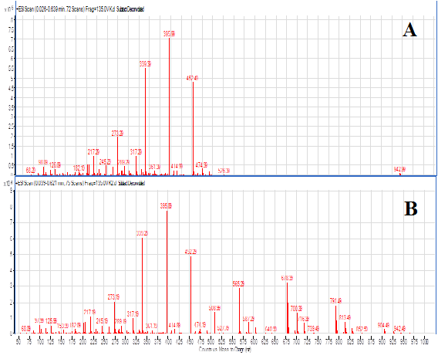
Figure 1.Mass spectroscopy of (A) pure MWCNT & (B) functionalized MWCNT. (Times New Roman front 8 Bold)

IR spectroscopy
The pure MWCNT has no obvious characteristic absorption peaks. The spectra of FMWCNT indicated intensive bands at ideal wavelengths shown in (figure 2).
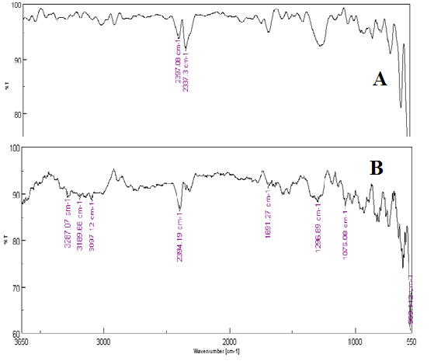
Figure 2.IR spectroscopy of (A) pure MWCNT & (B) functionalized MWCNT. (Times New Roman front 8 Bold)

Formulation of cefdinir loaded dry powder inhaler
Cefdinir was loaded using a slight modification in the Wetness Impregnation method.
The obtained microparticles suspension was lyophilized using mannitol (2.5% w/v) as a cryoprotectant to get cefdinir loaded FMWCNT carrier-based DPI¹⁸.

SEM study
The SEM image of cefdinir loaded FMWCNT has indicated flight like nature as shown in (figure 3). The flight like surface which increases the formulation fluidization and deep lung deposition. Whereas in the case of FMWCNT study, there was a clear surface The difference observed might be due to the cefdinir loading in the surface seen³⁰.

Figure 3. SEM image A) cefdinir loaded FMWCNT B) FMWCNT. (Times New Roman front 8 Bold)

Characterization of cefdinir loaded FMWCNTs based DPIEntrapment efficiency
Encapsulation efficiency for FMWCNT was 79.73% and for C-CEF-DPI it was a little less than theoretical i.e. 98.08%.

Flow properties
The powder has shown better angle of response which was 23±4.20°C (excellent), carr's index of 0.201±0.06 (g/cm³), and tapped density was 20.38±3.15 (below 15 % is considered as a poor stream), bulk density, and hausner's ratio of 0.204±0.05 (g/cm³), and 1.13 ± 3.15 (Below 1.25 Hausner's ratio shows the best flow characteristics than the greater one) which proved its acceptability as a carrier.

Drug content
The drug content of the F-CEF FMWCNT-DPI was 98.67 ± 0.32 % w/w.

Particle size determination
The particle size of an F-CEF FMWCNT-DPI was 5.25 ± 0.03 μm and for C-CEF DPI it was 7.54 ± 0.02 μm as depicted in (figure 4).
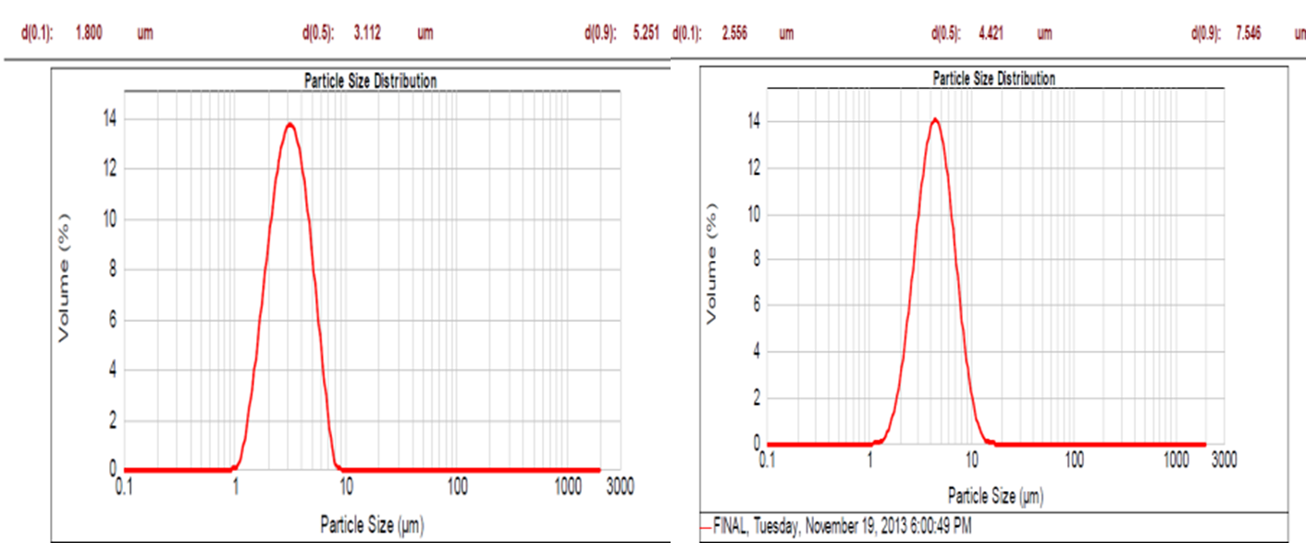
Figure 4. Particle size determination of F CEF FMWCNT DPI and C CEF DPI (Times New Roman front 8 Bold)

In vitro release study
The pure CEF results 37.26 ± 0.71 % of release and conventional cefdinir-DPI exhibited 35.38 ± 0.56 % of release in 3 h and then stopped the release. Whereas for formulated DPI showed the initial burst release of 24.30 ± 0.61 % and then showed drug release in a controlled manner for 15 hours i.e. 72.56 ± 0.78 % as shown in (figure 5).

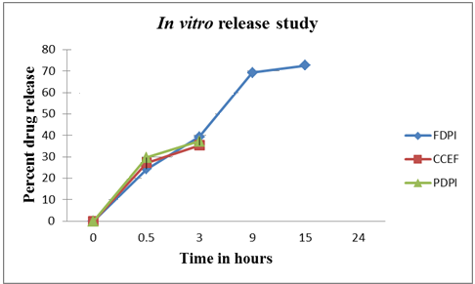
Figure 5.In vitro release study. (Times New Roman front 8 Bold)

Stability study
The F-CEF FMWCNT-DPI has shown 98.20 % of drug loading initially and after 3 months it was 97.28 %. The particle size of the formulation was 5.25 µm initially and after 3 months it was 6.32 µm. However, the F-CEF FMWCNT-DPI showed a gradual increase in particle size on storage at 40°C temperature and 75% RH as observed after 2 and 3 months, which is may be due to aggregates formed due to increase in moister content, increase in stability chamber (figure. 6).

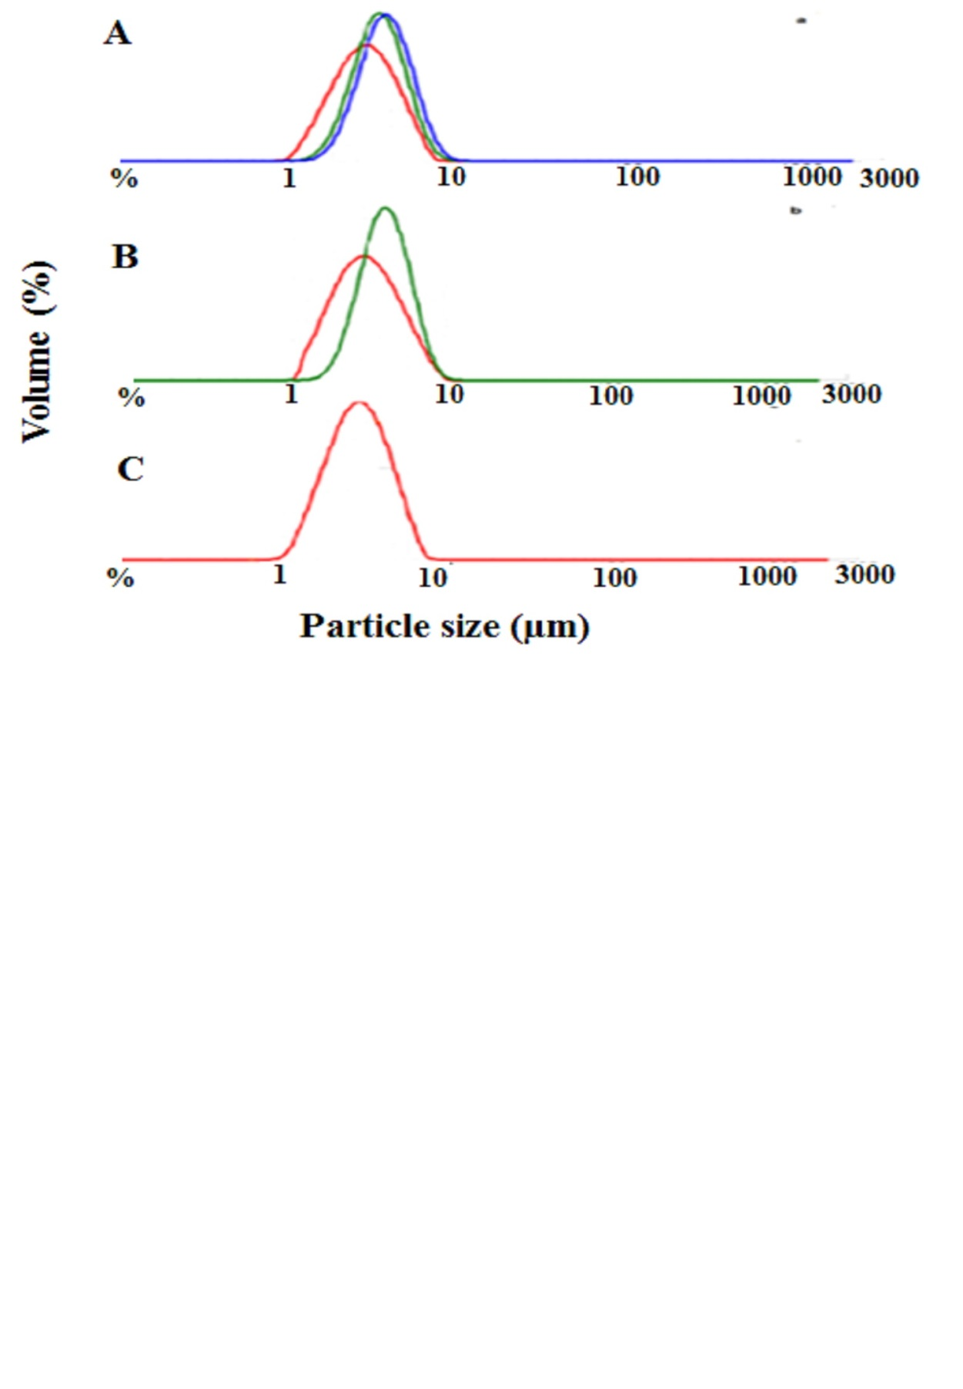
Figure 6. Particle size determination A) After 3 Months B) After 2 Month C) After 1 Month) (Times New Roman front 8 Bold)

In vitro deposition study using ACI
An aerodynamic characteristic of the F-CEF FMWCNT-DPI having required particle size and flow properties was assessed and compared with CCEF-DPI formulation by using an eight-stage, nonviable cascade impactor. The parameters such as MMAD, GSD, and FPF have prominently regulated the aerosolization and deposition of formulations in the lung. The Rotahaler was connected to ACI at 60 L/min to determine cefdinir content on each stage. The HPLC system specifications were as follows: Pump, PU-1580 (JASCO, Japan); Injector, auto sampler (AS-1555; JASCO); Column, HypersilC18, 250 × 4.6 mm, 5 μm (Thermo Electron Corporation, USA); Detector, UV/visible (UV-1575; JASCO). Data acquisition and analysis were carried out using Borwin/HSS 2000 software (LG 1580-04; JASCO). The mobile phase was a mixture of acetonitrile: methanol: water (13:5:2 v/v). The column temperature and flow rates were 40°C and 1 mL/min. The wavelength was 286 nm. The HPLC analytical reported method was well validated. The limit of detection and quantification for CEF was 5 to 25 ng/mL and retention time is 7.5 min. Whereas R² value was found to be 0.9996. The percent mass deposited for conventional and formulated cefdinir loaded FMCNTs DPI formulation on different stages of ACI is shown in (figure 7). The recovered dose (RD), emitted dose (ED), and fine particle dose (FPD) of conventional DPI and formulated cefdinir loaded DPI formulation were depicted in (Table 1). From the results, it can be stated that the MMAD ratio is more conventional than the formulated.

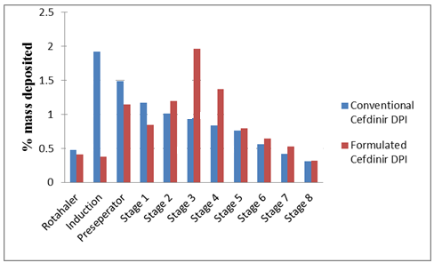
Figure 7.In vitro deposition profile of DPI’s in Andersen cascade impactor (Times New Roman front 8 Bold)

Table 1. Deposition profile of CCEF-DPI and F CEF FMWCNT-DPI in cascade impactor (Times New Roman front 8 Bold) Content (Times New Roman front 8 with Grid lines and left alignment)

Formulation | RD (mg) | ED (mg) | FPD (mg) | FPF (%) | MMAD (µm) | GSD (µm)
C-CEF DPI | 9.91±0.32 | 9.43±0.26 | 3.84±0.11 | 38.74±1.02 | 4.29±0.16 | 2.45±0.12
F-CEF FMWCNT-DPI | 9.62±0.23 | 9.21±0.21 | 5.63±0.16 | 58.52±1.06 | 3.45±0.09 | 1.58±0.10

DISCUSSION: (Times New Roman front 11 Bold Capital )
The Mass spectroscopy results indicated that highest mass to charge ratio in mass spectrum created due to the loss of an electron from a molecule, and it is concluded that after functionalization molecular weight was increased compared with pure MWCNT because of attachment of functional groups (OH, C=O) to the FMWCNT that confirms the functionalization. From IR results it is observed that oxygen containing groups (OH, C=O) in MWCNTs were present. More absorption peaks were observed in the spectra of functionalized MWCNT because after functionalization oxygen containing and some other groups were attached. It means there might be successful functionalization of the tube³¹. Results of MWCNTs from the current investigation have demonstrated that IR spectra of FMWCNT are instructive on explaining functionality at the surface. The SEM photographs indicated that cefdinir was loading on the surface. This was confirmed by the comparison of both the figure. The advantage of rod-shaped flight like particles is that they have a reduced tapped density. Furthermore, there is less contact between particles which results in a better fluidization and lung deposition³².There was a notable difference observed. Encapsulation efficiency for F-CEF FMWCNT-DPI was less than C-CEF-DPI, which means that it was effective in maintaining the drug inside or surface bonding during the process of drug loading. The tapped density of each powder can be used to predict both its flow properties and respirable fraction. Lowering the tapped density of the dry powders considerably enhances the respirable fraction. Carr's Index, Hausner ratio, and angle of repose commonly considered as proper criteria for the estimation of the flow properties of solids. The formulation exhibiting good flow properties displayed better deposition characteristics³³. The higher drug content (more than 98 %) was observed due to tight encapsulation of drugs with FMWCNT due to a higher acceptance ratio of it during drug loading, and also during freeze-drying, there was no drug loss observed. Particle size in the range of 1-6 μm has a vital role to get more deposition in the lung. Particles less than 1 μm shows less deposition efficiency and more than 6 μm are deposited in the throat²⁰. Because of this, from the results it can be stated that F-CEF FMWCNT-DPI showed particle size in the ideal range and C-DPI it was more than 6 μm, thus deposited in the throat.

In vitro release study F-CEF FMWCNT DPI showed the best drug release for up to 15 hours whereas the other groups showed release up to 3 hours and then stopped. The controlled release of all three groups is shown in figure 5. The controlled release pattern would be responsible for longer retention and improved efficacy of cefdinir³⁴.Stability study samples of F-CEF FMWCNT-DPI after storage for 3 months didn’t show any notable difference in the drug content and particle size. From the results of the stability study it is concluded that the F-CEF FMWCNT-DPI is stable without showing any variations in the drug content and particle size as shown in (table 2).
Table 2.In vitro release kinetics (Times New Roman front 8 Bold) Content (Times New Roman front 8 with Grid lines and left alignment)

Formulation | Zero order (r²) | First order (r²) | Higuchi (r²) | Peppas (r²)
Formulated DPI | 0.93 ± 0.09 | 0.79 ± 0.08 | 0.95 ± 0.13 | 0.90 ± 0.11
Conventional CEF DPI | 0.86 ± 0.10 | 0.67 ± 0.09 | 0.89 ± 0.07 | 0.86 ± 0.11
Pure CEF | 0.80 ± 0.12 | 0.57 ± 0.19 | 0.85 ± 0.08 | 0.84 ± 0.08

In vitro deposition study using ACI From the results, it can be stated that the MMAD ratio is more for convenience than the formulated this is because bulk and tapped density of the powder is determined for indicating the theoretical MMAD of the powder concerning its geometric diameter. The lower the density, the lower will be the MMAD of the powder.

CONCLUSION: (Times New Roman front 11 Bold Capital )
Functionalization of MWCNT was performed successfully to assess toxicity taking into consideration various parameters known to quantify functionalization and toxicity. It was observed that the functionalization of MWCNT reduced material toxicity. Additionally, it can be concluded that MWCNT after functionalization is safe, potential drug carrier in inhalation drug delivery and enhance regional lung deposition with better flow properties. The formulation of cefdinir loaded FMWCNTs DPI for drug delivery is useful to reduce the dose of the drug and synergistically enhance the activity against gram-positive and gram-negative bacteria due to site-specific delivery with increased bioavailability.

CONFLICT OF INTEREST: (Times New Roman front 11 Bold Capital )
The authors have no conflicts of interest regarding this investigation.

ACKNOWLEDGMENTS: (Times New Roman front 11 Bold Capital )
The authors would like to thank Dhande Pathlab Diagnostic Pvt. Ltd. Pune for their kind support during hematological and all other lab studies.

REFERENCES: (Times New Roman front 11 Bold Capital )

Content (Times New Roman front 8)

- Patil JS. Sarasija S. Pulmonary drug delivery strategies: A concise, systematic review. Lung India: Official Organ of Indian Chest Society. 2012; 29 (1):44.doi.org/10.4103/0970-2113.92361
- Shaji J. Shaikh M. Current development in the evaluation methods of pulmonary drug delivery system. Indian Journal of Pharmaceutical Sciences. 2016; 78(3):294-306. doi.org/10.4172/pharmaceutical-sciences.1000118
- Frijlink HW. De Boer AH. Dry powder inhalers for pulmonary drug delivery. Expert opinion on drug delivery. 2004; 1(1):67-86.doi.org/10.1517/17425247.1.1.67.
- Islam N. Gladki E. Dry powder inhalers (DPIs)—a review of device reliability and innovation. International journal of pharmaceutics. 2008; 360(1-2):1-1. Doi.org/ 10.1016/j.ijpharm.2008.04.044.
- Ballesteros B. Tobias G. Shao L. Pellicer E. Nogués J. Mendoza E. Green ML et al Steam Purification for the Removal of Graphitic Shells Coating Catalytic Particles and the Shortening of Single‐Walled Carbon Nanotubes. Small. 2008; 4(9):1501-6.doi.org/10.1021/ja061680u (Model Journal reference)
- Singh B. Lohan S. Sandhu PS. Jain A. Mehta SK. Functionalized carbon nanotubes and their promising applications in therapeutics and diagnostics. In Nanobiomaterials in Medical Imaging 2016; 455-478, William Andrew Publishing. https://doi.org/10.1021/nn700040t
- Mehra NK. Jain K and Jain NK. Pharmaceutical and biomedical applications of surface engineered carbon nanotubes. Drug Discovery Today. 2015; 20(6):750-9. doi.org/10.1016/j.drudis.2015.01.006
- Klinger-Strobel M. Lautenschläger C. Fischer D. Mainz JG. Bruns T. Tuchscherr L. Pletz MW. Makarewicz O. Aspects of pulmonary drug delivery strategies for infections in cystic fibrosis–where do we stand?. Expert Opinion on Drug Delivery. 2015; 12(8): 1351-74. Doi.org/ 10.1517/17425247.2015.1007949.
- Strausbaugh SD. Davis PB. Cystic Fibrosis: A Review of Epidemiology and Pathology. Clinics in Chest Medicine.2007; 28(2): 279-88. doi.org/ 10.1016/j.ccm.2007.02.011.
- Palmer GC. Whiteley M. Metabolism and pathogenicity of Pseudomonas aeruginosa infections in the lungs of individuals with cystic fibrosis. Metabolism and Bacterial Pathogenesis. 2015;185-213.https://doi.org/10.3389/fmicb.2015.00321
- MizgerdJP. Lung infection—a public health priority. PLoS Med. 2006; 3(2):e76. https://doi.org/10.1371/journal.pmed.0030076
- Oliver A. Cantón R. Campo P. Baquero F. Blázquez J. High frequency of hypermutable Pseudomonas aeruginosa in cystic fibrosis lung infection. Science. 2000; 288(5469): 1251–1253. doi.org/10.1126/science.288.5469.1251.
- Guay DR. Cefdinir: an advanced-generation, broad-spectrum oral cephalosporin. Clinical therapeutics 2002; 24(4):473–489. doi.org/10.1016/s0149-2918(02)85125-6
- Sader HS. Jones RN. Cefdinir: an oral cephalosporin for the treatment of respiratory tract infections and skin and skin structure infections. Expert review of anti-infective therapy 2007; 5(1):29–43. Doi.org/ 10.1586/14787210.5.1.29.
- Perry CM. Scott LJ. Cefdinir. Drugs 2004; 64(13): 1433–1464. doi.org/10.2165/00003495-200464130-00004
- Ghoshal S. Kushwaha SKS. Srivastava M. Tiwari P. Drug loading and release from functionalized multiwalled carbon nanotubes loaded with 6-mercaptopurine using incipient wetness impregnation method. Am J Adv Drug Del. 2014; 2(2):213–223.
- Misra A. Tyagi PK. Rai P. Misra DS. FTIR Spectroscopy of multiwalled carbon nanotubes: a Simple approach to study the nitrogen doping. Journal of nanoscience and nanotechnology 2007; 7(6):1820–1823.
- Li Y. Wang T. Wang J. Jiang T. Cheng G. Wang S. Functional and unmodified MWNTs for delivery of the water-insoluble drug Carvedilol–A drug-loading mechanism. Applied Surface Science 2011; 257(13): 5663–5670. https://doi.org/10.1021/ar020259h
- Tang L. Zhang H. Han J. Wu X. Zhang Z. Fracture mechanisms of epoxy filled with ozone functionalized multi-wall carbon nanotubes. Composites science and technology 2011; 72(1):7–13. https://doi.org/10.1016/j.compositesa.2014.04.023
- Mali AJ. Pawar AP. Bothiraja C. Improved lung delivery of budesonide from biopolymer based dry powder inhaler through natural inhalation of rat. Materials Technology2014; 29(6): 350–357. https://doi.org/10.1179/1753555714Y.0000000163
- Bansal S. Aggarwal G. Chandel P. Harikumar SL. Design and development of cefdinirniosomes for oral delivery. J Pharm Bioallied Sci. 2013; 5(4): 318–25.doi.org/ 10.4103/0975-7406.120080
- Abdullah EC. Geldart D. The use of bulk density measurements as flowability indicators. Powder technology 1999; 102(2):151–165. doi.org/ 10.1208/s12249-013-9994-5
- Honmane S. Hajare A. More H. Osmani RAM. Salunkhe S. Lung delivery of nanoliposomal salbutamol sulfate dry powder inhalation for facilitated asthma therapy. Journal of liposome research 2019; 29(4):332–342. doi.org/10.1080/08982104.2018.1531022
- Blott SJ. Croft DJ. Pye K. Saye SE. Wilson HE. Particle size analysis by laser diffraction. Geological Society, London, Special Publication. 2004; 232(1):63-73. doi.org/10.1144/GSL.SP.2004.232.01.08
- Shazly G. Nawroth T. Langguth P. Comparison of dialysis and dispersion methods for in vitro release determination of drugs from multilamellar liposomes. Dissolution technologies 2008; 15(2):7. doi.org/10.14227/DT150208P7
- Dhumal RS. Biradar SV. Paradkar AR. York P. Particle engineering using sonocrystallization: salbutamol sulphate for pulmonary delivery. International journal of pharmaceutics. 2009; 368(1–2):129–137. doi.org/: 10.1016/j.ijpharm.2008.10.006
- Hassan MS. Lau RWM. Effect of particle shape on dry particle inhalation: study of flowability, aerosolization, and deposition properties. Aaps Pharmscitech. 2009; 10(4): 1252. doi.org/10.1208/s12249-009-9313-3
- Ma-Hock L. Strauss V. Treumann S. Küttler K. Wohlleben W. Hofmann T. Comparative inhalation toxicity of multi-wall carbon nanotubes, graphene, graphite nanoplatelets and low surface carbon black. Particle and fibre toxicology. 2013; 10(1): 23. doi.org/ 10.1186/1743-8977-10-23
- Ji JH. Jung JH. Kim SS. Yoon JU. Park JD. Choi BS. Twenty-eight-day inhalation toxicity study of silver nanoparticles in Sprague-Dawley rats. Inhalation toxicity.2007; 19(10):857-87. doi.org/10.1080/08958370701432108.
- Jafarinejad S. Gilani K. Moazeni E. Ghazi Khansari M. Najafabadi AR. Mohajel N. Development of chitosan-based nanoparticles for pulmonary delivery of itraconazole as dry powder formulation. Powder technology.2012; 222:65–70. doi.org/10.4103/0250-474X.110584
- Osswald S. Havel M. Gogotsi Y. Monitoring oxidation of multiwalled carbon nanotubes by Raman spectroscopy. Journal of Raman Spectroscopy An International Journal for Original Work in all Aspects of Raman Spectroscopy, Including Higher Order Processes, and also Brillouin and Rayleigh Scattering. 2007; 38(6):728–736. doi.org/10.1002/jrs.1686
- Auriemma A.S. Dry powder inhalers of gentamicin and leucine: formulation parameters, aerosol performance and in vitro toxicity onCuFi1 cells. Int J Pharm.2012; 426 (1-2): 100-107. doi.org/10.1016/j.ijpharm.2012.01.026
- Dolatabadi JEN. Hamishehkar H. Valizadeh H. Development of dry powder inhaler formulation loaded with alendronate solid lipid nanoparticles: solid-state characterization and aerosol dispersion performance. Drug Development and Industrial Pharmacy. 2015; 41(9):1431–7. doi.org/ 10.3109/03639045.2014.956111.
- Siepmann J. Faisant N. Akiki J. Richard J. Benoit JP. Effect of the size of biodegradable microparticles on drug release: experiment and theory. Journal of Controlled Release.2004; 96(1):123–134. doi: 10.1016/j.jconrel.2004.01.011.

